Experts Estimate 1.1 Million Acres of Dicamba Damage
July 26, 2018 02:52 PM

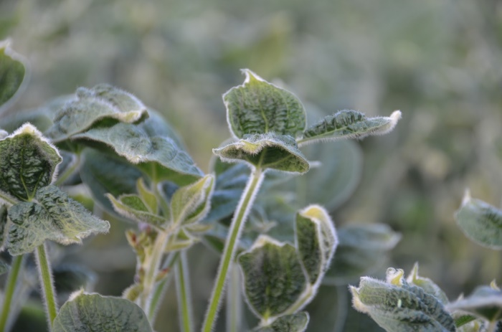
© Sonja Begemann
By Sonja Begemann
Farm Journal
Seeds and Crop Production Editor
As of July 15, farmers, homeowners and others filed 605 official complaints of suspected dicamba damage with state departments of agriculture across soybean growing states. That number reflects soybeans and all other specialty crops including vegetable plants, fruit trees, ornamentals, trees, etc.
However, university Extension experts estimate that not all cases of off-target movement have been reported. They estimate 1.1 million total acres of soybeans alone have received damage this season. This includes Arkansas, which has an in-season dicamba ban, at 400,000 estimated acres of damage with 155 official complaints.
“I can’t really say this year is an improvement over last year,” says Kevin Bradley, University of Missouri Extension weed scientist, who puts these estimates together with the help of other Extension weed scientists. “In Missouri we have 156 complaints as of yesterday (July 23), 80 from the Bootheel and I expect the number in the rest of the state to grow.”
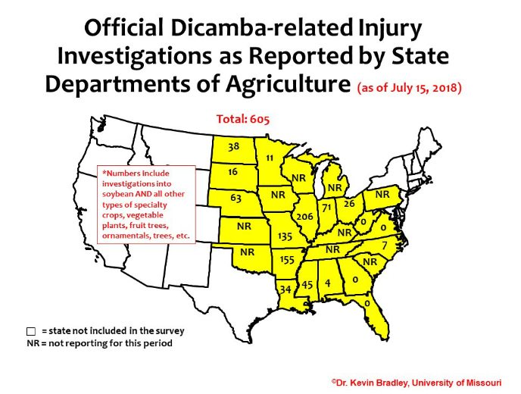
The Bootheel of Missouri is about 95% Roundup Ready 2 Xtend soybeans, so he anticipated that region of the state would have fewer complaints than the rest of the state. “We’re seeing northwest and northern Missouri have way more problems, it’s yet to be determined how bad it’s going to be,” Bradley says.
Compared to this time last year (July 25, the first report on dicamba damage from Bradley) there were 1,411 dicamba-related investigations across soybean growing states. At that time, weed scientists estimated 2.5 million acres of soybeans had been injured with dicamba.
“It should be noted that these totals (the current number of acres, 1.1 million, and complaints, 605) do not reflect what has happened in those states who were unwilling to participate and provide information for this survey,” Bradley said in a recent post.
Current numbers also reflect label changes, mandatory training and cut-off dates in certain states, such as Missouri and Arkansas.
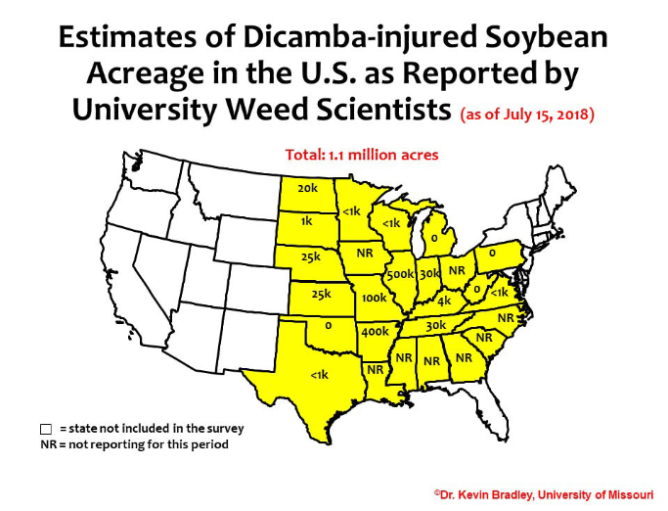
Companies say training and label changes made a positive difference.
Monsanto reports it’s had 381 calls and visited 299 of those farms with complaints as of July 12. Ryan Rubischko, Monsanto dicamba portfolio lead, said in a recent interview there has been some symptomology related to dicamba, but some of those symptoms mimic dicamba damage and was caused by other issues.
Overall, BASF has had fewer calls alleging off-target movement than last year, said Gary Schmitz, BASF regional manager for technical services, in a recent interview. He believes that stewardship training efforts and applicators working hard to follow the label have made an impact.
Both companies agree that this year’s training, which reached more than 95,000 applicators between the three registrants (BASF, Corteva and Monsanto) and states, has made a difference. This training focused on understanding label requirements, such as what conditions lead to temperature inversions, downwind sensitive plants and drift reduction requirements.

